IFG Adventure 3rd Year

Term Four - Week One Snapz Interest
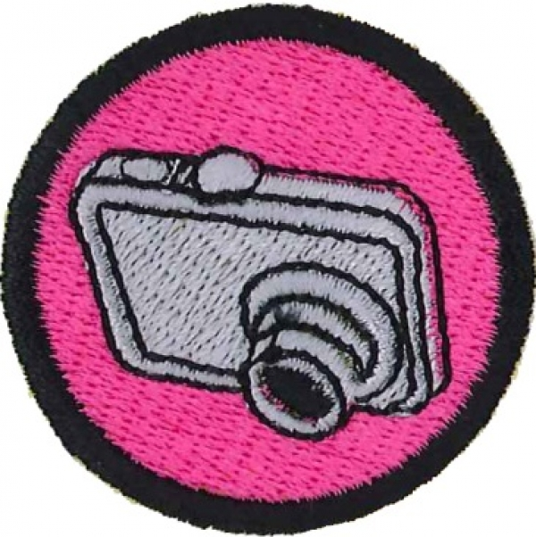
Aim:
To produce a set of photographs to illustrate an article about your IFG Unit for publication in the GB/IFG Newsrap magazine.

Objectives:
- To teach girls the functionality of a digital camera
- To introduce girls to the principles of good photo composition
- To teach girls how to organise their human subjects so they cooperate and have fun being photographed

Equipment Needed:
- As digital cameras can be expensive, it is unlikely that all girls will own a camera of their own or if they do, be allowed to bring them along to IFG. For this subject it will be better if you enlist the aid of sufficient leaders / adult helpers with digital cameras so that each leader has a group of no more than three girls to supervise.
- Cameras and Lap tops to download photos to
- Data projector
- Internet access
- Screen or blank wall
- Back copies of Newsrap magazines (extra copies available free from the IFG Resource Centre)

Preparation:
- You may wish to invite a photographer or members of a camera club to come along and teach the girls how to create a ‘perfect’ photo.
- Introduce your visitors to the girls and explain why they are there.

SetUp:
Commence the formal part of the evening with roll call etc.

Devotions:
Ask the girls “How do you know what you look like?” Some may answer “By looking in a mirror” or “By looking at a photo of me” or “By seeing myself on a video”.
“Do you know that most of us have a “mirror” face? We tend to compose our face before looking in a mirror. That’s why when we see a reflection of ourselves unexpectedly – like in a shop window – we can look different to what we usually look like in a mirror.
Most of us will have had the experience of meeting someone for the very first time and thinking “She looks nice” even though you don’t know her at all.
There is a verse in the bible – Second Corinthians Chapter 3 verse 18 that says “And we, who with unveiled faces all reflect the Lord’s glory, are transformed into his likeness with ever-increasing glory, which comes from the Lord, who is the Spirit”.
You may like to have a discussion here with the girls about the faces of models that are depicted in magazines and the faces of real girls. Are you more likely to see a face reflecting the Lord’s glory on a magazine cover or on someone special that you know?
Prayer:

Activity Session:
- If you have internet access show the girls the website of a professional photographer eg www.woolf.co.nz
- Form into small groups with a leader with a camera for each group. Leaders will explain the functions of his/her camera.
- Still in their small groups look at back copies of Newsrap and critique the photos. What made a good interesting photo, what photos were poorly composed?
- The girls may then try taking some photos which are then downloaded onto a laptop and critiqued by the group.
- Get leaders to email the best photos to the Senior Leader for inclusion in a Power Point Presentation next week.

Notices and Home Time:
End evening with a prayer

